

KAUNAS UNIVERSITY OF TECHNOLOGY

FACULTY OF INFORMATICS

T120B166 Development of Computer Games and Interactive Applications

*3D Labyrinth*

|  |
| --- |
| *IFF 8/7 Gvidas Raškevičius* |
|  |
| Date: *2021.05.11* |

Kaunas, 2021

Tables of Contents

Tables of Images 3

Table of Tables/functions 4

Description of Your Game 5

Laboratory work #1 6

List of tasks 6

Solution 6

Task #1. *Getting a Character* 6

Task #2. *Making character move with animations* 7

Task #3. *Adding more game objects and lights* 9

Task #4. *Making player die when saw touches him and giving points when collecting it* 11

Task #5. *Stopping the game* 11

Defense task. *Make it so that the player would be able to run (sprint) for only for a certain amount of time (configurable, e.g. 5 seconds). Then after running, there would be a cool-down (configurable, e.g. 1 second) after the player could run again.* 12

Laboratory work #2 13

List of tasks 13

Solution 13

Task #1. *Building world environment* 13

Task #2. *Fixing Lab #1 defense task* 18

Task #3. *Adding animations to game character* 19

Task #4. Creating / animating game objects 19

Task #5. Creating particles for game objects 21

Task #6. Adding custom skybox 22

Task #7. Creating physics material 22

Task #8. Creating objects that uses collision or triggers 25

Task #9. Baking a lightmap 26

Defense task. - Add a "wall" which would have a shattering animation - If the player touches the wall, the animation should play and the player should be able to pass through the shattered wall - When the animation finishes, a "dust" particle effect should play out 26

Laboratory work #3 28

List of tasks 28

Solution 28

Task #1. *Adding menu system* 28

Task #2. *Adding options menu* 29

Task #3. *Adding GUI* 30

Task #4. *Adding scoring system based on time / points / health collected* 32

Task #5. *Game over condition* 33

Task #6. *Adding shooting* 33

Task #7. *Interactive sounds* 33

Task #8. *Post processing* 36

Defense task - Save player score to disk - When the player finishes the game, show a list of previous player scores - Names are not important, can be random number or random string 36

User's manual 38

Literature list 39

ANNEX 40

# **Tables of Images**

Figure 1. Character 6

Figure 2. Wall 9

Figure 3. Sawblade 10

Figure 4. Point 10

Figure 5. Start end platforms 10

Figure 6. Stamina UI 18

Figure 7. Animations 19

Figure 8. Point 19

Figure 9. Health point 20

Figure 10. Sawblade 20

Figure 11. Ice floor 23

Figure 12. Honey floor 23

Figure 13. Regular floor 23

Figure 14. Main menu with a baked lightmap 26

Figure 15. Main menu 28

Figure 16 Options menu 30

Figure 17. GUI 31

Figure 18. Score 32

Figure 19 Game over 33

Figure 20 Audio mixers 34

Figure 21 Without post processing 36

Figure 22 With post procesing 36

Figure 23 Registry file with saved data 37

Figure 24. Main Menu 38

Figure 25. Levels menu 38

# **Table of Tables/functions**

Table 1. Move function 8

Table 2. OnTriggerEnter and OnCollisionEnter function 11

Table 3. player.Win(), player.Lose() functions 12

Table 4. player.Defense task 12

Table 5. MazeGenerator 14

Table 6. Randomly generated objects 15

Table 7. Starting point, floors generated 16

Table 8. Generating the maze 17

Table 9. Stamina for running and regenerating it 18

Table 10. Setting the threshold. 19

Table 11. Heart controller 20

Table 12. Sawblade controller 21

Table 13. Particles 22

Table 14. Different physics materials 24

Table 15. Triggers and collisions 25

Table 16. Defense task 27

Table 17 Main menu controller functions 29

Table 18. Settings controller 30

Table 19. Code to control GUI 31

Table 20. Code for score calculations 32

Table 21. Game over condition 33

Table 22 Shooting implementation 33

Table 23 Music selector script for controlling the audio in game 35

Table 24 Defense task 37

# **Description of Your Game**

Description of Your Game.

1. 3D or 2D? *3D*
2. What type is your game? Puzzle
3. What genre is your game? Racing
4. Platforms (mobile, PC or both?) PC
5. Scenario Description. *Žaidimo idėja – išeiti labirintą per kuo trumpesnį laiką. Žaidimo veikėjas ( nenuspręsta kas, žmogus, robotas ar kažkas kitas) turi rasti išėjimą per labirintą pilną kliūčių (tarpai kuriuos reik prašokti, judantys pjūklai ir t.t) per kuo trumpesnį laiką. Kuo ilgiau jis užtrunka tuo mažiau taškų gale gauna. Duodamos 3 gyvybės. Kiekvienam lygį yra checkpoint, kuriuos praėjus jeigu žaidėjas miršta , nusikelia į checkpointus. Jei išnaudojamos visos gyvybės, skelbiamas game over ir žaidėjas lygį turi pradėti nuo pradžių. Kuo didesnis lygis, tuo sunkesni ir ilgesni lygiai. Lygių generavimui bandyčiau sukurti algortimą kad juos generuotų automatiškai, tačiau nesu tikras ar tai pavyks įgyvendinti tai neatmetu varianto, kad juos galėčiau generuoti tik rankiniu būdų.*

**Laboratory work #1**

**List of tasks** (main functionality of your project)

1. Getting a Character
2. Making character movement with animations
3. Adding more game objects and lights
4. Making player die when saw touches him and giving points when player collects them
5. Stopping the game

# **Solution**

## **Task #1. *Getting a Character***

Description of the implementation (3-5 sentences). For character I chose free character from asset store (Source #1). It has free textures as well as animations, so I chose it to quick understand how everything works. For future I think I will be able to create my own character with Blender, or make it from objects in Unity itself.

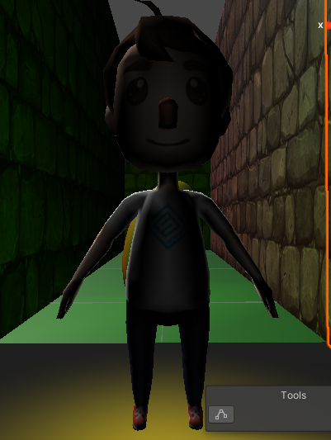

Figure 1. Character

## **Task #2. *Making character move with animations***

Description of the implementation (3-5 sentences). For making my character move, I created a movementController. It has these properties:

* movementSpeed – how fast character moves at the moment.
* walkingSpeed – how fast character moves when walking.
* runningSpeed - how fast character moves when running.
* jumpHeight – how high can character jump.
* isGrounded – checks whether the character is on the ground
* groundCheckDistance – distance when character is on the ground and when it’s not. For instance, if you set it 2, the character will be in y level 2 and it will understand that character is on the ground.
* groundMask – layer that is defined as a ground
* gravity – Gravity for when character jumps. It may be set, however I intend to make it static in future.

As well as properties, my controller has references to CharacterController and Animator for animations.

Main functionality is in Move() function. Additional to that there is Jump, Run, Walk and Idle functions.

private void Move()

{

isGrounded = Physics.CheckSphere(transform.position, groundCheckDistance, groundMask);

if(isGrounded && velocity.y < 0)

{

velocity.y = -2f;

}

float moveZ = Input.GetAxis("Vertical");

float moveX = Input.GetAxis("Horizontal");

moveDirection = new Vector3(moveX, 0, moveZ);

moveDirection = transform.TransformDirection(moveDirection);

if (isGrounded)

{

if(moveDirection != Vector3.zero && !Input.GetKey(KeyCode.LeftShift))

{

Walk();

}

else if(moveDirection != Vector3.zero && Input.GetKey(KeyCode.LeftShift)){

Run();

}

else if(moveDirection == Vector3.zero)

{

Idle();

}

moveDirection *= movementSpeed;

if (Input.GetKeyDown(KeyCode.Space))

{

Jump();

}

}

controller.Move(moveDirection * Time.deltaTime); //movement

velocity.y += gravity * Time.deltaTime;

controller.Move(velocity * Time.deltaTime); //gravity

}

Table 1. Move function

private void Walk()

{

movementSpeed = walkingSpeed;

anim.SetFloat("Speed", 0.25f, 0.1f, Time.deltaTime);

}

private void Run()

{

movementSpeed = runningSpeed;

anim.SetFloat("Speed", 0.5f, 0.1f, Time.deltaTime);

}

private void Idle()

{

anim.SetFloat("Speed", 0,0.1f,Time.deltaTime);

}

private void Jump()

{

velocity.y = Mathf.Sqrt(jumpHeight * -2 * gravity);

movementSpeed = walkingSpeed;

anim.SetFloat("Speed", 0.75f);

}

Table 3. Additional functions

## **Task #3. *Adding more game objects and lights***

Description of the implementation (3-5 sentences). For game objects I needed walls to generate a labyrinth with, as well as ground, starting and end platforms. Also I added saw that I drew myself with Blender and animated it to spin. Also, added points that I created with unity 3d object sphere.

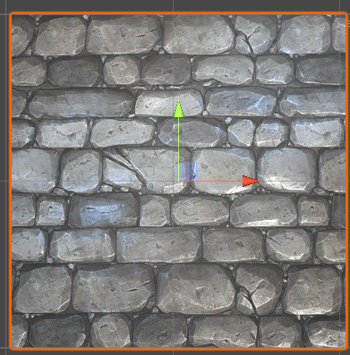

Figure 2. Wall

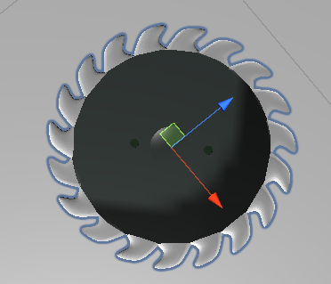

Figure 3. Sawblade

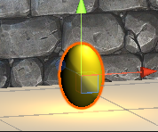

Figure 4. Point

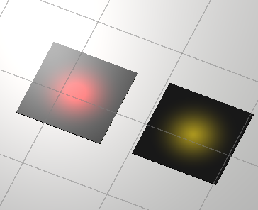

Figure 5. Start end platforms

## **Task #4. *Making player die when saw touches him and giving points when collecting it***

Description of the implementation (3-5 sentences). For that, I have created a triggerController for player. There is function onTriggerEnter and onCollisionEnter. onTriggerEnter is for collecting points, onCollisionEnter is for detecting collision with the saw, and if it does that stops the game and says that it is game over.

private void OnTriggerEnter(Collider other)

{

var otherGameObject = other.gameObject;

var collected = false;

if(other.tag == "Point")

{

player.AddPoints(pointValue);

collected = true;

}else if(other.tag == "Finish")

{

player.Win();

}

if (collected)

{

otherGameObject.SetActive(false);

Destroy(otherGameObject);

}

}

void OnCollisionEnter(Collision other)

{

var otherGameObject = other.gameObject;

if (otherGameObject.tag == "Saw")

{

player.Lose();

}

}

Table 2. OnTriggerEnter and OnCollisionEnter function

## **Task #5. *Stopping the game***

Description of the implementation (3-5 sentences). It is quite simple code, if player steps on end platform, OnTriggerEnter from previous code activates and calls player.Win() function. If it gets killed by saw, it calls player.Lose() function. If you wish to reset the scene for a new round, I implemented simple code by pressing R you just refresh the scene.

public void Win()

{

pointsText.gameObject.SetActive(false);

movementController.enabled = false;

finishText.text = $"You win!\nYou scored {points} points.";

finishText.gameObject.SetActive(true);

}

public void Lose()

{

pointsText.gameObject.SetActive(false);

movementController.enabled = false;

finishText.text = $"You lose!\nYou scored {points} points.";

finishText.gameObject.SetActive(true);

}

Table 3. player.Win(), player.Lose() functions

## **Defense task. *Make it so that the player would be able to run (sprint) for only for a certain amount of time (configurable, e.g. 5 seconds). Then after running, there would be a cool-down (configurable, e.g. 1 second) after the player could run again.***

Description of the implementation (3-5 sentences). I tried to make that you set starting time when it starts to run and a simple if statement whether to check if that time is higher than runningTime set and cooldown, however after player ran for given time, it couldn’t run no more, a bug with a time I believe.

private void Run()

{

float start = Time.time;

if (start > seconds + cooldown )

{

start = Time.time ;

Debug.Log($"Please wait {cooldown}s before sprinting again.");

movementSpeed = walkingSpeed;

anim.SetFloat("Speed", 0.25f, 0.1f, Time.deltaTime);

}

else

{

movementSpeed = runningSpeed;

anim.SetFloat("Speed", 0.5f, 0.1f, Time.deltaTime);

}

}

Table 4. player.Defense task

**Laboratory work #2**

**List of tasks** (main functionality of your project)

1. Building world environment
2. Fixing Lab #1 defense task
3. Adding animations to game character
4. Creating / animating game objects
5. Creating particles for game objects
6. Adding custom skybox
7. Creating physics materials
8. Creating objects that uses different colliders or triggers
9. Baking a lightmap

# **Solution**

## **Task #1. *Building world environment***

Description of implementation (3-5 sentences). *This part is made out of two scripts : Maze generator and maze renderer.*

* *Maze generator works with a backtracker algorithm. The idea is simple – you give it width and height of the maze, and it randomly chooses the starting point. The algorithm is designed that it starts at random position and finds all neighbours that he can visit. Once it visits a coordinate, it is added to the stack. If there is no unvisited neighbours from the last coordinate, he pops the stack and looks for unvisited neighbours from previous coordinate and it continues until the stack is empty.*
* *Maze renderer then gets the stack with coordinates that maze is made of, and puts the prefabs that we give it for floors and walls to make the maze. It is pushed to the sides that it would make a path instead of the walls. We also generate random objects like ice floor, honey floor, saws, life points and points in the maze in this part. For that we have different prefabs ready and functions that instantiate these objects.*

private static Wall[,] generateMaze(Wall[,] maze, int width, int height,int seed)

{

var rng = new System.Random(seed);

var positionStack = new Stack<Position>();

var position = new Position { X = rng.Next(0,width), Y = rng.Next(0, height) };

maze[position.X, position.Y] |= Wall.VISITED; // 1000 1111

positionStack.Push(position);

while(positionStack.Count > 0)

{

var current = positionStack.Pop();

var neighbours = getUnvisitedNeighbours(current, maze, width, height);

if(neighbours.Count > 0)

{

positionStack.Push(current);

var randIndex = rng.Next(0, neighbours.Count);

var randomNeighbour = neighbours[randIndex];

var nPosition = randomNeighbour.Position;

maze[current.X, current.Y] &= ~randomNeighbour.SharedWall;

maze[nPosition.X, nPosition.Y] &= ~getOppositeWall(randomNeighbour.SharedWall);

maze[nPosition.X, nPosition.Y] |= Wall.VISITED;

positionStack.Push(nPosition);

}

}

return maze

}

Table 5. MazeGenerator

void GenerateSaws()

{

var r = new System.Random();

for (int i = 0; i < NumOfSaws; i++)

{

int rX = r.Next((-Width - 1) / 2, Height / 2);

int rY = r.Next((-Height - 1) / 2, Height / 2);

var sawblade = Instantiate(sawPrefab, transform);

var sawController = GetComponentInChildren<SawMovement>();

if( i % 2==0 ) sawController.toggleXAxis();

sawblade.position = new Vector3(rX, 0.5f, rY);

}

}

void GeneratePoints()

{

var r = new System.Random();

for (int i = 0; i < NumOfPoints; i++)

{

int rX = r.Next((-Width - 1) / 2, Height / 2);

int rY = r.Next((-Height - 1) / 2, Height / 2);

var point = Instantiate(pointPrefab, transform);

point.position = new Vector3(rX, 0.25f, rY);

}

}

void GenerateHearts()

{

var r = new System.Random(23);

for (int i = 0; i < NumOfHearts; i++)

{

int rX = r.Next((-Width - 1) / 2, Height / 2);

int rY = r.Next((-Height - 1) / 2, Height / 2);

var point = Instantiate(heartPrefab, transform);

point.position = new Vector3(rX, 0f, rY);

}

}

Table 6. Randomly generated objects

void generateStartEnd()

{

var startPlatform = Instantiate(startObject, transform);

startPlatform.position = new Vector3(0, 0, 0);

var endPlatform = Instantiate(endObject, transform);

var rnd = Random.Range(1, 4);

switch (rnd)

{

case 1:

endPlatform.position = new Vector3(-Width / 2, 0, (Height - 1) / 2);

break;

case 2:

endPlatform.position = new Vector3((Width - 1) / 2, 0, -Height / 2);

break;

case 3:

endPlatform.position = new Vector3((Width - 1) / 2, 0, (Height - 1) / 2);

break;

case 4:

endPlatform.position = new Vector3(-Width / 2, 0, -Height / 2);

break;

}

}

public void generatePlayer()

{

playerPrefab.position = new Vector3(0, 0, 0);

}

void placeIceFloor(Vector3 position)

{

var icyFloor = Instantiate(icyFloorPrefab, transform);

icyFloor.localScale = new Vector3(icyFloor.localScale.x, icyFloor.localScale.y, icyFloor.localScale.z);

icyFloor.position = position + new Vector3(0, -1, 0);

}

void placeHoney(Vector3 position)

{

var honeyFloor = Instantiate(honeyPrefab, transform);

honeyFloor.localScale = new Vector3(honeyFloor.localScale.x, honeyFloor.localScale.y, honeyFloor.localScale.z);

honeyFloor.position = position + new Vector3(0, -1, 0);

}

void placeFloor(Vector3 position)

{

var floor = Instantiate(floorPrefab, transform);

floor.localScale = new Vector3(floor.localScale.x, floor.localScale.y, floor.localScale.z);

floor.position = position + new Vector3(0, -1, 0);

}

Table 7. Starting point, floors generated

private void Draw(Wall[,] maze)

{

generatePlayer();

generateStartEnd();

GenerateSaws();

GeneratePoints();

GenerateHearts();

for (int i = 0; i < Width; i++)

{

for (int j = 0; j < Height; j++)

{

var cell = maze[i, j];

var position = new Vector3(-Width / 2 + i, 1f, -Height / 2 + j);//OFFSET of the middle of the cell, so there's a path

var rnd = Random.Range(1, 11);

if(rnd > 6 && rnd <=9)

{

placeIceFloor(position);

}

else if(rnd > 9)

{

placeHoney(position);

}

else

{

placeFloor(position);

}

if (cell.HasFlag(Wall.UP))

{

var topWall = Instantiate(wallPrefab, transform) as Transform;

topWall.position = position + new Vector3(0, 0, size/2);

topWall.localScale = new Vector3(size, topWall.localScale.y, topWall.localScale.z);

}

if (cell.HasFlag(Wall.LEFT))

{

var leftWall = Instantiate(wallPrefab, transform) as Transform;

leftWall.position = position + new Vector3(-size / 2, 0, 0);

leftWall.localScale = new Vector3(size, leftWall.localScale.y, leftWall.localScale.z);

leftWall.eulerAngles = new Vector3(0, 90, 0);

}

if (i == Width - 1)

{

if (cell.HasFlag(Wall.RIGHT))

{

var rightWall = Instantiate(wallPrefab, transform) as Transform;

rightWall.position = position + new Vector3(size / 2, 0, 0);

rightWall.localScale = new Vector3(size, rightWall.localScale.y, rightWall.localScale.z);

rightWall.eulerAngles = new Vector3(0, 90, 0);

}

}

if (j == 0)

{

if (cell.HasFlag(Wall.DOWN))

{

var bottomWall = Instantiate(wallPrefab, transform) as Transform;

bottomWall.position = position + new Vector3(0, 0, -size / 2);

bottomWall.localScale = new Vector3(size, bottomWall.localScale.y, bottomWall.localScale.z);

}

}

}

}

}

Table 8. Generating the maze

## **Task #2. *Fixing Lab #1 defense task***

Description of implementation (3-5 sentences). *Added a user interface bar for stamina, that is getting lower once you run. After the set time of cooldown, it starts to generate back if you do not run. If you run out of stamina, you’re not able to run anymore and have to wait until it charges back up.*

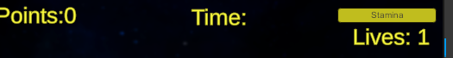

Figure 6. Stamina UI

[Range(0,10)][SerializeField] private float stamina=10;

[Range(0, 10)] [SerializeField] private float maxStamina = 10;

private float StaminaRegenTimer = 0.0f;

private const float staminaDecrease = 2.0f;

private const float staminaIncrease = 5.0f;

private void Run()

{

if (stamina > 0)

{

stamina = Mathf.Clamp(stamina - (staminaDecrease * Time.deltaTime), 0.0f, maxStamina);

movementSpeed = runningSpeed;

anim.SetFloat("Speed", 0.5f, 0.1f, Time.deltaTime);

StaminaRegenTimer = 0.0f;

}

else

{

Walk();

}

}

private void RegenerateStamina()

{

if (StaminaRegenTimer >= cooldown)

{

stamina = Mathf.Clamp(stamina + (staminaIncrease * Time.deltaTime), 0.0f, maxStamina);

}

else

{

StaminaRegenTimer += Time.deltaTime;

}

}

Table 9. Stamina for running and regenerating it

## **Task #3. *Adding animations to game character***

Description of implementation (3-5 sentences). *I used a character from asset store, so it had his animations ready, I only had to implement it, which I did. Implementation is pretty simple, I just have to set what Threshold to use when walking, running, jumping and idling.*

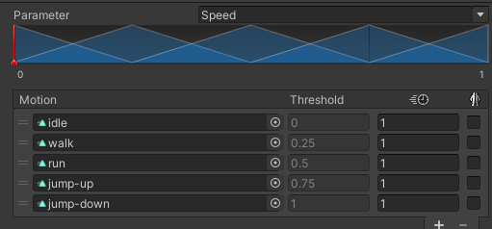

Figure 7. Animations

anim.SetFloat("Speed", 0,0.1f,Time.deltaTime);

anim.SetFloat("Speed", 0.25f, 0.1f, Time.deltaTime);

anim.SetFloat("Speed", 0.5f, 0.1f, Time.deltaTime);

anim.SetFloat("Speed", 0.75f);

Table 10. Setting the threshold.

## **Task #4. Creating / animating game objects**

Description of implementation (3-5 sentences). *I added Sawblade, Life point and point objects to the game. For other 2 game objects I would consider them starting and ending platforms.*

* Sawblade was created by me in blender, I animated it there as well. It has only spinning animation, and for movement, I made a simple script that controls the movement of the blade by moving it on x or y axis randomly by set distance.
* Point was created from a simple sphere in unity, animation was only adding some particles and making a shaders that would look like pulsating
* Health point was taken from a internet, link to it is added in the source list. For animation I just made a simple controller that spins the heart and added shaders for pulsating look.

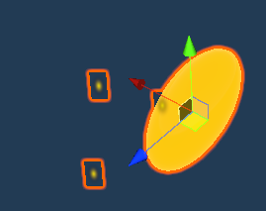

Figure 8. Point

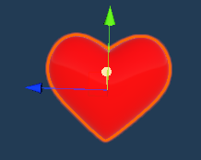

Figure 9. Health point

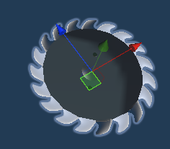

Figure 10. Sawblade

public class HeartController : MonoBehaviour

{

void Update()

{

Spin();

}

void Spin()

{

transform.Rotate(0, 50*Time.deltaTime, 0);

}

}

Table 11. Heart controller

public class SawMovement : MonoBehaviour

{

[SerializeField] private float speed = 1.0f;

[SerializeField] private float blockMovement = 3;

[SerializeField] private bool xAxis = false;

private Vector3 pos;

private Vector3 posX;

private Vector3 posY;

void Start()

{

pos = transform.position;

posX = new Vector3(pos.x + blockMovement, pos.y, pos.z);

posY = new Vector3(pos.x, pos.y, pos.z+ blockMovement);

}

void Update()

{

if (xAxis)

{

xAxisMovement();

}

else

{

yAxisMovement();

}

}

void xAxisMovement()

{

transform.position = Vector3.Lerp(pos, posX, Mathf.PingPong(Time.time * speed, 1.0f));

}

void yAxisMovement()

{

transform.position = Vector3.Lerp(pos, posY, Mathf.PingPong(Time.time * speed, 1.0f));

}

public void toggleXAxis()

{

xAxis = true;

}

}

Table 12. Sawblade controller

## **Task #5. Creating particles for game objects**

Description of implementation (3-5 sentences). *For particles, I used 4 of them at the moment, did not have where to use a 5th one , unfortunately. I implemented it on heart pickup, for emitting particles to show player where is the points, when he get hits by the sawblade and when it steps on the icy floor.*

private void createHeartParticles(Vector3 position)

{

Instantiate(heartParticlePrefab, position, Quaternion.identity);

}

private void createBloodParticles(Vector3 position)

{

Instantiate(bloodPrefab, position, Quaternion.identity);

}

private void OnTriggerEnter(Collider other)

{

var otherGameObject = other.gameObject;

var collected = false;

else if(other.tag == "Heart")

{

player.AddHealthPoint(heartValue);

SoundSource.PlayOneShot(heartSound);

createHeartParticles(otherGameObject.transform.position);

collected = true;

}

if (otherGameObject.tag == "Saw")

{

player.removeHealthPoint();

createBloodParticles(other.transform.position);

SoundSource.PlayOneShot(sawSound);

}

}  
  
//////

if (icy)

{

moveDirection = lastMoveDirection * slideSpeed;

if (!isParticleRunning)

{

Instantiate(snowParticles,transform.localPosition, Quaternion.identity);

isParticleRunning = true;

}

canJump = true;

}

Table 13. Particles

## **Task #6. Adding custom skybox**

Description of implementation (3-5 sentences). *At this step, I just took the free skybox assets from asset store, which had cubemaps, so it gives me a good quality skyboxes and I can change them if I wish easily as well. The source for it will be in the source lists.*

## **Task #7. Creating physics material**

Description of implementation (3-5 sentences). *I have decided to go with 3 physics materials – solid ground, icy ground and honey combs. If you step on icy, it gives you a feeling that you’re sliding by taking your last position and multiplying it by slide speed that you set. On honey comb, you’re moving a lot slower and you are not able to jump at all.*

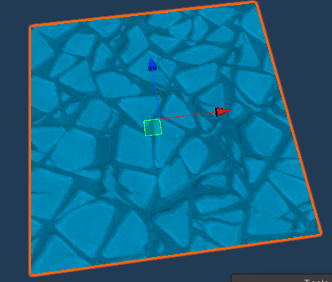

Figure 11. Ice floor

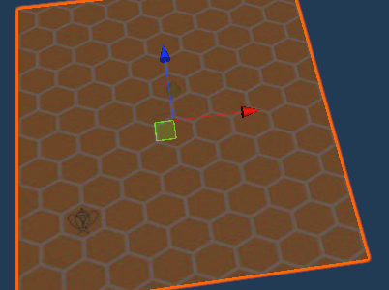

Figure 12. Honey floor

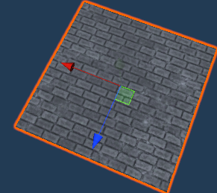

Figure 13. Regular floor

private bool icy = false;

private bool honey = false;

void OnControllerColliderHit(ControllerColliderHit hit)

{

icy = hit.collider.CompareTag("Ice");

honey = hit.collider.CompareTag("Honey");

}

private void Move()

{

isGrounded = Physics.CheckSphere(transform.position, groundCheckDistance, groundMask);

if(isGrounded && velocity.y < 0)

{

velocity.y = -2f;

}

float moveZ = Input.GetAxis("Vertical");

float moveX = Input.GetAxis("Horizontal");

float inputMagnitude = Mathf.Min(new Vector3(moveX, 0, moveZ).sqrMagnitude, 1f);

moveDirection = new Vector3(moveX, 0, moveZ);

moveDirection = transform.TransformDirection(moveDirection);

if(inputMagnitude > 0.225f)

{

lastMoveDirection = moveDirection;

}

if (isGrounded)

{

if (icy)

{

moveDirection = lastMoveDirection * slideSpeed;

if (!isParticleRunning)

{

Instantiate(snowParticles,transform.localPosition, Quaternion.identity);

isParticleRunning = true;

}

canJump = true;

}

else if(honey)

{

DestroyAll("Snow");

isParticleRunning = false;

moveDirection *= honeySpeed;

canJump = false;

}

else

{

DestroyAll("Snow");

isParticleRunning = false;

canJump = true;

if(moveDirection != Vector3.zero && !Input.GetKey(KeyCode.LeftShift))

{

Walk();

}

else if(moveDirection != Vector3.zero && Input.GetKey(KeyCode.LeftShift)){

Run();

}

else if(moveDirection == Vector3.zero)

{

Idle();

}

moveDirection *= movementSpeed;

}

if (Input.GetKeyDown(KeyCode.Space))

{

Jump(canJump);

}

}

controller.Move(moveDirection * Time.deltaTime); //movement

velocity.y += gravity * Time.deltaTime;

controller.Move(velocity * Time.deltaTime); //gravity

}

Table 14. Different physics materials

## **Task #8. Creating objects that uses collision or triggers**

Description of implementation (3-5 sentences). *My previously showed game objects uses colliders and triggers. Heart point on trigger enter gets destroyed, lets out a sound and burst a particle effects. Point also lets out a sound and gets destroyed. My saw blade on collision enter takes out a life of your life points and plays a sound with activating blood particle effects as well. Also, there is an trigger on the finish tile, when you step on it, a win menu displays allowing you to go to next level.*

private void OnTriggerEnter(Collider other)

{

var otherGameObject = other.gameObject;

var collected = false;

if(other.tag == "Point")

{

player.AddPoints(pointValue);

SoundSource.PlayOneShot(pointSound);

collected = true;

}else if(other.tag == "Finish")

{

player.Win();

SoundSource.PlayOneShot(finishSound);

}

else if(other.tag == "Heart")

{

player.AddHealthPoint(heartValue);

SoundSource.PlayOneShot(heartSound);

createHeartParticles(otherGameObject.transform.position);

collected = true;

}

if (collected)

{

otherGameObject.SetActive(false);

Destroy(otherGameObject);

}

}

void OnCollisionEnter(Collision other)

{

var otherGameObject = other.gameObject;

if (otherGameObject.tag == "Saw")

{

player.removeHealthPoint();

createBloodParticles(other.transform.position);

SoundSource.PlayOneShot(sawSound);

}

}

Table 15. Triggers and collisions

## **Task #9. Baking a lightmap**

Description of implementation (3-5 sentences). *Since my levels is generated automatically, I am not able to bake a lightmap, so I made it on the main menu, that took sample scene with a baked lightning.*

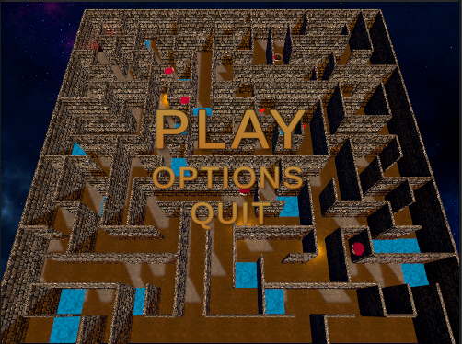

Figure 14. Main menu with a baked lightmap

## **Defense task.** - Add a "wall" which would have a shattering animation - If the player touches the wall, the animation should play and the player should be able to pass through the shattered wall - When the animation finishes, a "dust" particle effect should play out

Description of the implementation (3-5 sentences). I made one singular wall, then made another prefab with a lot of small cubes that makes the same wall, once the collider triggers, small cubes gets spawned and the old wall gets deleted, it makes it look like it shattered, and on top of that I let out particle system.

using System.Collections;

using System.Collections.Generic;

using UnityEngine;

public class WallController : MonoBehaviour

{

[SerializeField] private GameObject shatterPrefab;

[SerializeField] private GameObject wallParticles;

void Start()

{

}

void Update()

{

}

void OnCollisionEnter(Collision other)

{

Debug.Log(gameObject.transform.position);

Instantiate(shatterPrefab,gameObject.transform.position,gameObject.transform.rotation);

Instantiate(wallParticles, transform.localPosition, Quaternion.identity);

Destroy(gameObject);

}

}

Table 16. Defense task

**Laboratory work #3**

**List of tasks** (main functionality of your project)

1. Adding menu system
2. Adding options menu
3. Adding GUI
4. Adding scoring system based on time / points / health collected
5. Game over condition
6. Adding shooting
7. Interactive sounds
8. Post Procesing

# **Solution**

## **Task #1. *Adding menu system***

Description of implementation (3-5 sentences). *Added a simple menu with options, choose level, start or quit options.*

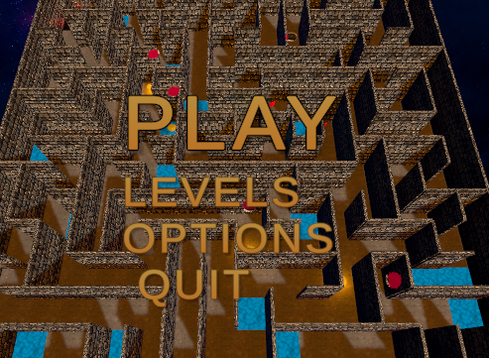

Figure 15. Main menu

In the case of using functions, the description of each main function should be completed with the source code FRAGMENTS (the functions should be indexed in a separate table of contents);

private static void Show(Component component)

{

component.gameObject.SetActive(true);

}

private static void Hide(Component component)

{

component.gameObject.SetActive(false);

}

private void Start()

{

ShowMainMenu();

}

public void StartGame()

{

SceneManager.LoadScene("Level", LoadSceneMode.Single);

}

public void ExitGame()

{

Scenes.ExitGame();

}

public void ShowMainMenu()

{

Show(mainMenu);

Hide(optionsMenu);

Hide(levelsMenu);

}

public void ShowOptionsMenu()

{

Show(optionsMenu);

Hide(mainMenu);

}

public void ShowLevelsMenu()

{

Show(levelsMenu);

Hide(mainMenu);

}

public void SelectLevel(string levelName)

{

SceneManager.LoadScene(levelName, LoadSceneMode.Single);

}

Table 17 Main menu controller functions

## **Task #2. *Adding options menu***

Description of implementation (3-5 sentences). *Here I made a simple options menu for controlling effects and music sounds and if you wish to play a fullscreen or not game.*

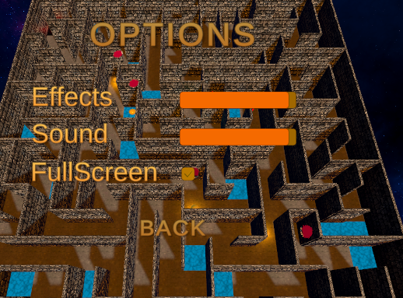

Figure 16 Options menu

public AudioMixer musicAudioMixer;

public AudioMixer effectsAudioMixer;

public Slider musicSlider;

public Slider effectSlider;

public void SetVolumeMusic(float volume)

{

musicSlider.value = volume;

musicAudioMixer.SetFloat("MusicVolume", volume);

}

public void SetVolumeEffects(float volume)

{

effectSlider.value = volume;

effectsAudioMixer.SetFloat("EffectVolume", volume);

}

public void SetFullscreen(bool isFullscreen)

{

Screen.fullScreen = isFullscreen;

}

Table 18. Settings controller

## **Task #3. *Adding GUI***

Description of implementation (3-5 sentences). *I have added a simple text GUI which best fits my needs. It has a timer, points, health point, stamina and ammo.*

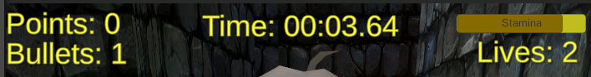

Figure 17. GUI

In the case of using functions, the description of each main function should be completed with the source code FRAGMENTS (the functions should be indexed in a separate table of contents);

public void AddPoints(int value)

{

points += value;

UpdatePointsText();

}

public void AddHealthPoint(int value)

{

if(healthPoints < maxHealthPoints)

{

healthPoints += value;

UpdateHealthPointsText();

}

}

public void removeHealthPoint()

{

if(healthPoints > 0)

{

healthPoints -= 1;

UpdateHealthPointsText();

}

else

{

Lose();

}

}

private void UpdatePointsText()

{

pointsText.text = $"Points: {points}";

}

private void UpdateBulletsText()

{

bulletsText.text = $"Bullets: {bullets}";

}

private void UpdateHealthPointsText()

{

healthPointsText.text = $"Lives: {healthPoints}";

}

void Start()

{

staminaBar.maxValue = movController.getMaxStamina();

staminaBar.value = movController.getStamina();

}

private void Update()

{

staminaBar.value = movController.getStamina();

if (staminaBar.value == 0)

{

staminaText.text = $"{System.Math.Round(movController.getCooldown() *-1)}s. cooldown";

}

else

{

staminaText.text = "Stamina";

}

}

Table 19. Code to control GUI

## **Task #4. *Adding scoring system based on time / points / health collected***

Description of implementation (3-5 sentences). *There was used a simple line of code to get how much time were used to completing the level, calculating the points and lives points and then taking away time spent points.*



Figure 18. Score

private int CalculateScore(int points,int healthPoints)

{

int minus = 0;

double milliseconds = timerController.getTime().TotalMilliseconds;

if (milliseconds > 10000)

{

minus = -20;

}else if(milliseconds > 15000)

{

minus = -50;

}

else if (milliseconds > 20000)

{

minus = -70;

}

else if (milliseconds > 25000)

{

minus = -100;

}

else if (milliseconds > 30000)

{

minus = -200;

}

else

{

minus = 0;

}

return points * 100 + healthPoints * 50 + minus;

}

Table 20. Code for score calculations

## **Task #5. *Game over condition***

Description of implementation (3-5 sentences). *The game is over if character loses all his health points.*

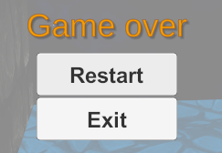

Figure 19 Game over

if(healthPoints > 0)

{

healthPoints -= 1;

UpdateHealthPointsText();

}

else

{

Lose();

}

Table 21. Game over condition

## **Task #6. *Adding shooting***

Description of implementation (3-5 sentences). *I used a simple 3 line code to spawn a new object from a given position and launching it towards front and after 3 seconds the object is destroyed. If the “bullets” tag hits the wall it gets destroyed. Haven’t added animations yet to the collapsing and also need to make a protection to outer walls, however shooting is fully functional.*

private void Shoot()

{

if(Input.GetButtonDown("Fire1") && bullets> 0)

{

Rigidbody bulletInstance = Instantiate(bulletPrefab, firePosition.position, firePosition.rotation) as Rigidbody;

bulletInstance.velocity = transform.TransformDirection(0, 0, bulletSpeed);

bullets--;

UpdateBulletsText();

Destroy(bulletInstance.gameObject, 3);

}

}

Table 22 Shooting implementation

## **Task #7. *Interactive sounds***

Description of implementation (3-5 sentences). *I have added steps, sounds when getting hit, when on ice, main music of different 3 songs and 1 different for main menu. Used 2 different audio mixers for effect and main music to control the volume of them independently.*

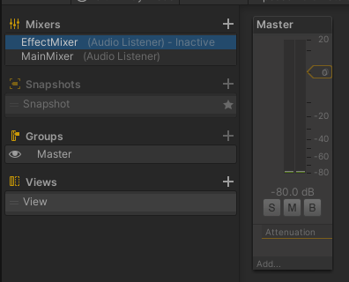

Figure 20 Audio mixers

public AudioSource Track1;

public AudioSource Track2;

public AudioSource Track3;

public int TrackSelector;

public int TrackHistory;

void Start()

{

TrackSelector = Random.Range(0, 3);

if(TrackSelector == 0)

{

Track1.Play();

TrackHistory = 0;

}

else if(TrackSelector == 1)

{

Track2.Play();

TrackHistory = 1;

}

else if(TrackSelector == 2)

{

Track3.Play();

TrackHistory = 2;

}

}

void Update()

{

if (Track1.isPlaying == false && Track2.isPlaying == false && Track3.isPlaying == false)

{

TrackSelector = Random.Range(0, 3);

if (TrackSelector == 0 && TrackHistory != 0)

{

Track1.Play();

}

else if (TrackSelector == 1 && TrackHistory != 1)

{

Track2.Play();

}

else if(TrackSelector == 2 && TrackHistory != 2)

{

Track3.Play();

}

}

}

Table 23 Music selector script for controlling the audio in game

## **Task #8. *Post processing***

Description of implementation (3-5 sentences). *Post processing was made using the tutorial from lecturers, it makes the world a little bit nicer, with a darker tone.*

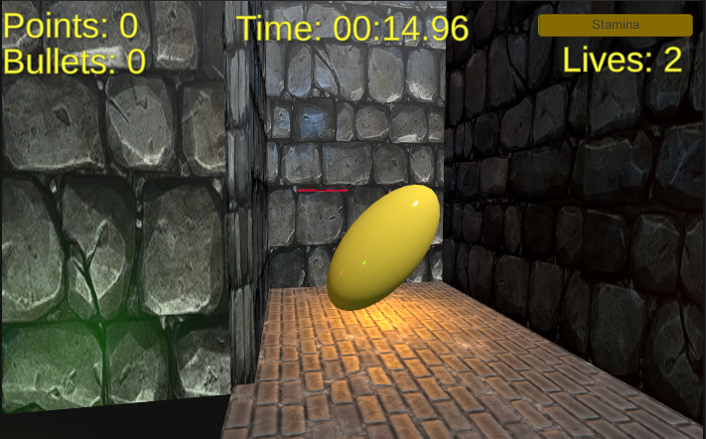

Figure 21 Without post processing

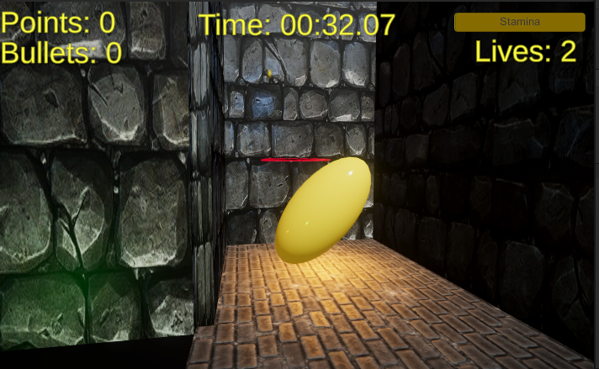

Figure 22 With post procesing

## **Defense task** - Save player score to disk - When the player finishes the game, show a list of previous player scores - Names are not important, can be random number or random string

Description of the implementation (3-5 sentences). I used playerPrefs to save the data to registry, with random numbers that was my mistake, should have used static names for scores, then I use the same method for retrieving them and simple GUI to show the score I retrieve from registry.

private void SaveScore()

{

generatedNums = new List<int>();

int rnd = Random.Range(0, 999);

generatedNums.Add(rnd);

PlayerPrefs.SetInt($"Score", CalculateScore(points,healthPoints));

rnd++;

}

public void loadScores()

{

score1 = PlayerPrefs.GetInt("Score718");

scorefromDBText.text = $"Your score from DB = {score1}";

}

Table 24 Defense task

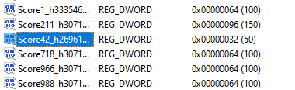

Figure 23 Registry file with saved data

**User's manual** (for the Individual work defence)

**How to play?** *The goal of the game is to find the ending platform (red) and collect as many as you can points / health points as fast as you can. In order to start the game, you need to press PLAY, or go to LEVELS and choose the level you wish to play.*

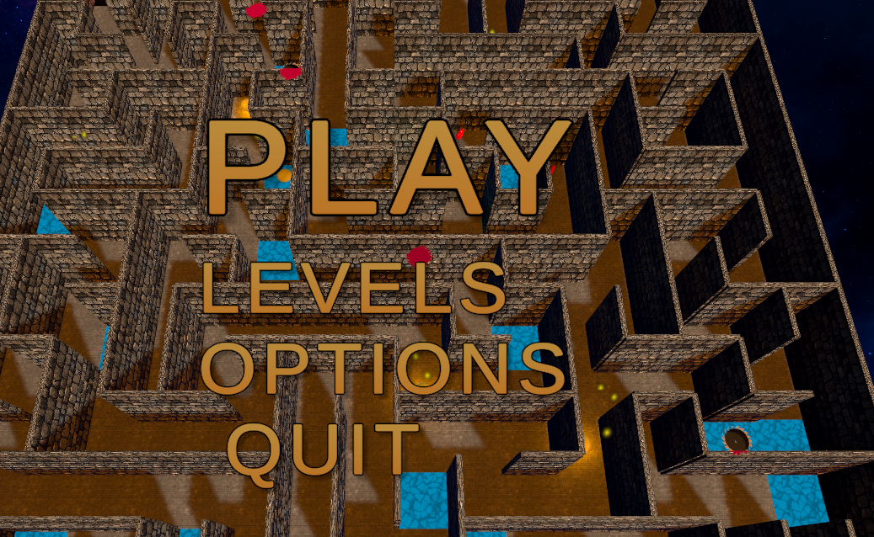

Figure 24. Main Menu

*In the levels menu you can choose the level you wish to play. The higher the level, the larger the maze and the more enemies there are.*

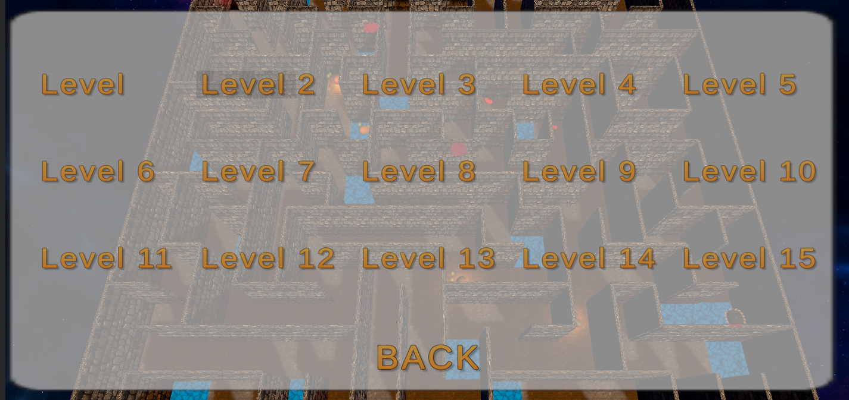

Figure 25. Levels menu

**Descriptions of the rules of the game**. Rules is simple – finish the game as fast as possible without dying.

**Descriptions of the controls / keys.**

* W,A,S,D or Arrow keys - Movement
* MOUSE – Direction the character is looking at
* SPACE – jumps
* SHIFT – runs

**You can download the game from :** https://github.com/gviras/3DLab

# **Literature list**

1. Source #1. [*https://assetstore.unity.com/packages/3d/characters/humanoids/character-pack-free-sample-79870*](https://assetstore.unity.com/packages/3d/characters/humanoids/character-pack-free-sample-79870)
2. Source #2. <https://free3d.com/3d-model/valentine39s-day-heart-69073.html> - Heart model
3. Source #3. <https://assetstore.unity.com/packages/vfx/particles/spells/magic-vfx-ice-free-170242> - Ice particles
4. Source #4. <https://assetstore.unity.com/packages/vfx/particles/blood-gush-73426> - Blood particles
5. Source #5. <https://assetstore.unity.com/packages/2d/textures-materials/floors/20-man-made-ground-materials-12835> - Floor material
6. Source #6. <https://assetstore.unity.com/packages/audio/sound-fx/foley/footsteps-essentials-189879> - Sounds used
7. Source #7. <https://assetstore.unity.com/packages/audio/sound-fx/free-casual-game-sfx-pack-54116> - Sounds used
8. Source #8. <https://assetstore.unity.com/packages/2d/textures-materials/sky/skybox-series-free-103633> - Skyboxes
9. Desert Caravan by Aaron Kenny

Music promoted on https://www.chosic.com/

1. Art of silence by uniq

https://soundcloud.com/uniqofficial

Attribution 4.0 International (CC BY 4.0)

https://creativecommons.org/licenses/by/4.0

Music promoted by https://www.chosic.com

1. Time and Space by Keys of Moon | https://soundcloud.com/keysofmoon

Attribution 4.0 International (CC BY 4.0)

https://creativecommons.org/licenses/by/4.0/

Music promoted by https://www.chosic.com/

1. Yugen - Emotional Ethnic Music by Keys of Moon | https://soundcloud.com/keysofmoon

Attribution 4.0 International (CC BY 4.0)

https://creativecommons.org/licenses/by/4.0/

Music promoted by https://www.chosic.com/

# **ANNEX**

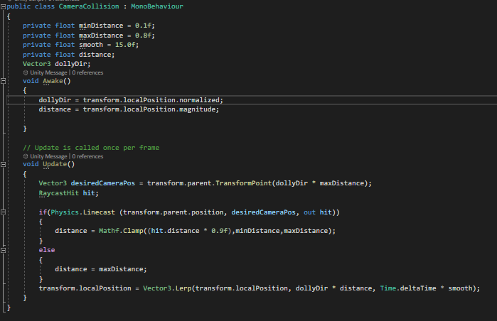

Kodas 1 CameraCollision.cs

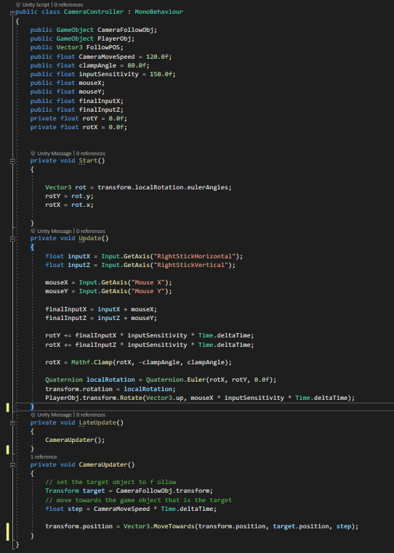

Kodas 2 CameraController

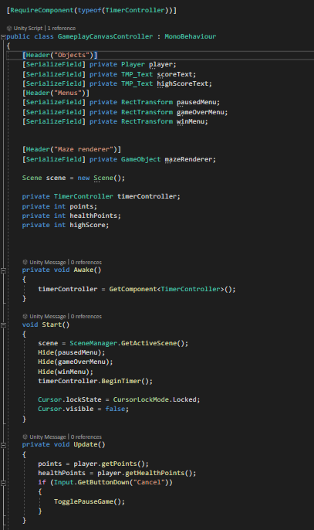

Kodas 3 GameplayCanvasController 1

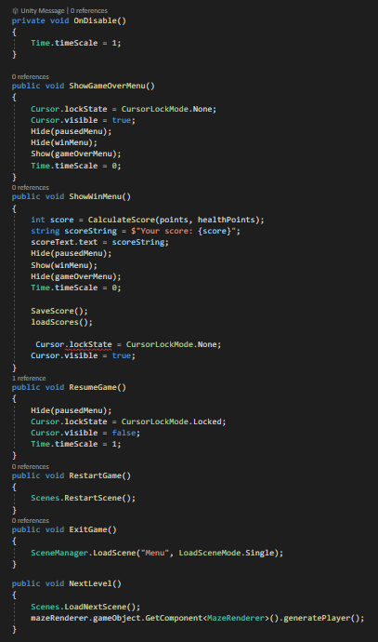

Kodas 4 GameplayCanvasController 2

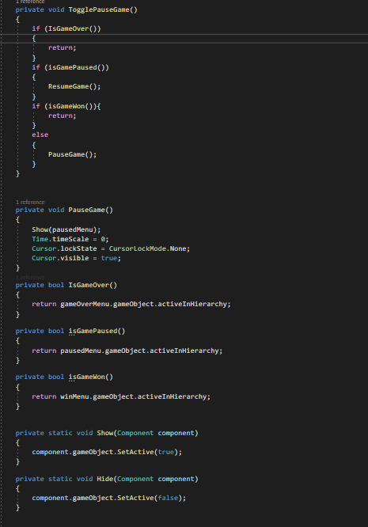

Kodas 5 GameplayCanvasController 3

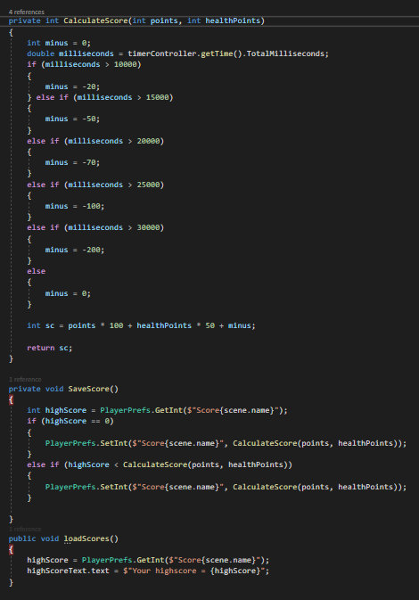

Kodas 6 GameplayCanvasController 4

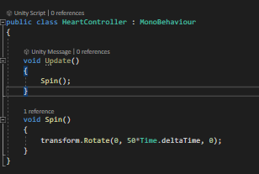

Kodas 7 HeartController

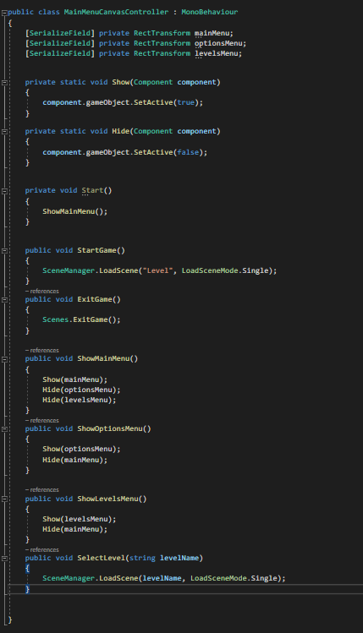

Kodas 8 MainMenuCanvasController

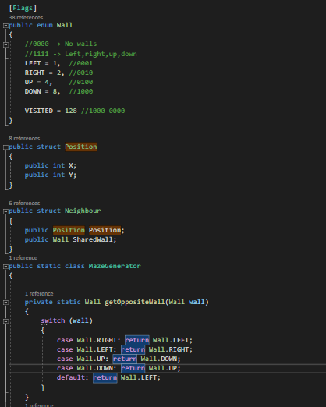

Kodas 9 MazeGenerator 1

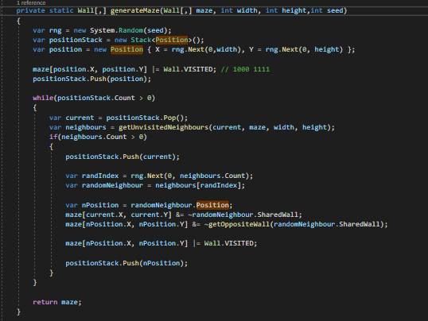

Kodas 10 MazeGenerator 2

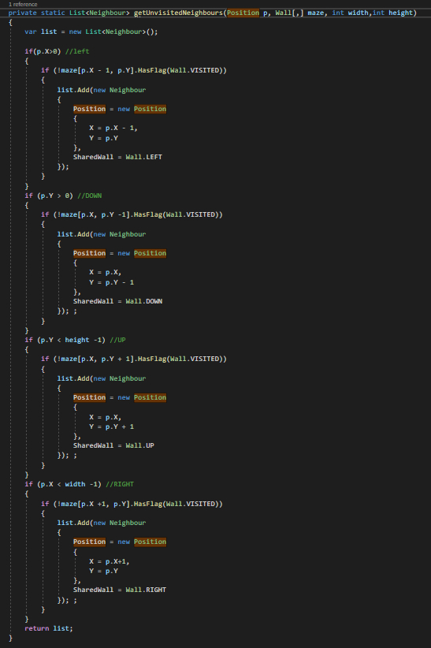

Kodas 11 MazeGenerator 3

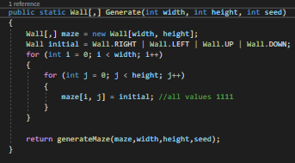

Kodas 12 MazeGenerator 4

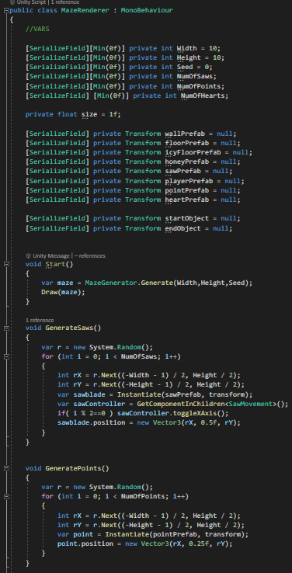

Kodas 13 MazeRenderer 1

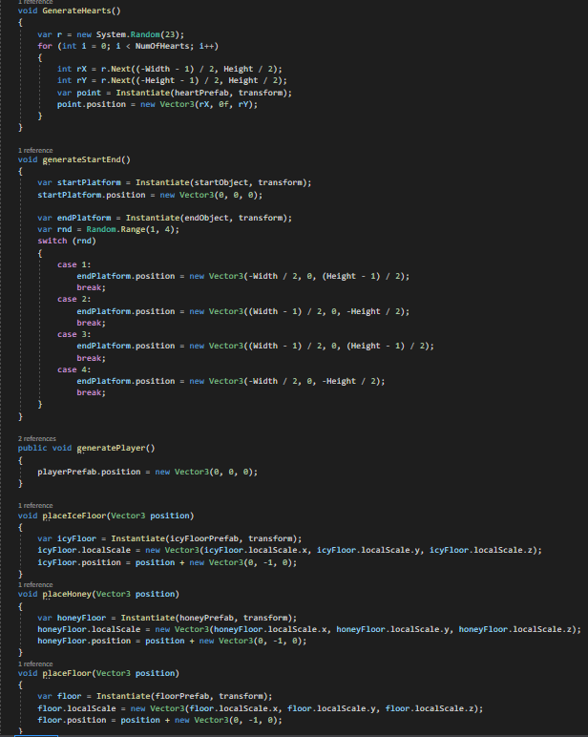

Kodas 14 MazeRenderer 2

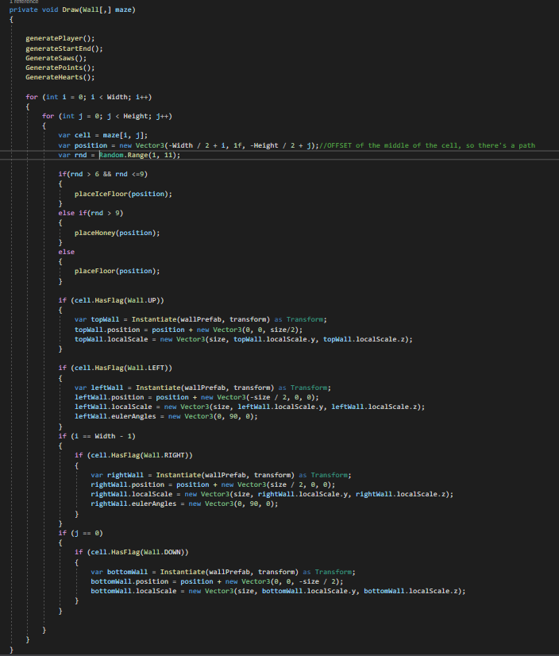

Kodas 15 MazeRenderer 3

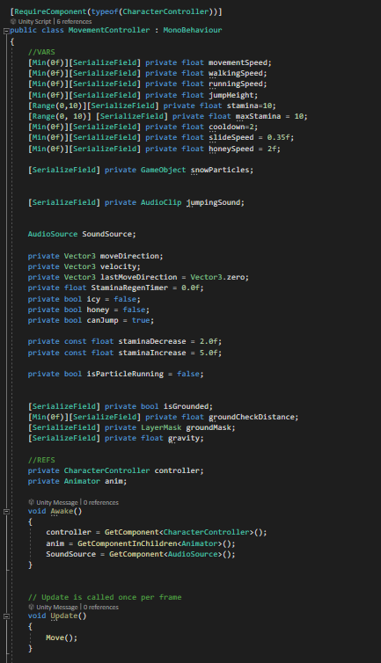

Kodas 16 MovementController 1

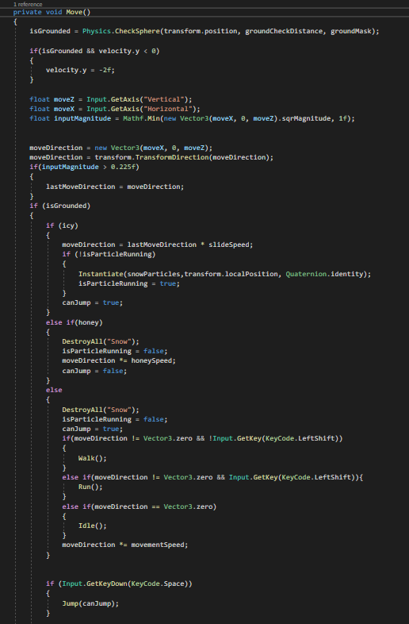

Kodas 17 MovementController 2

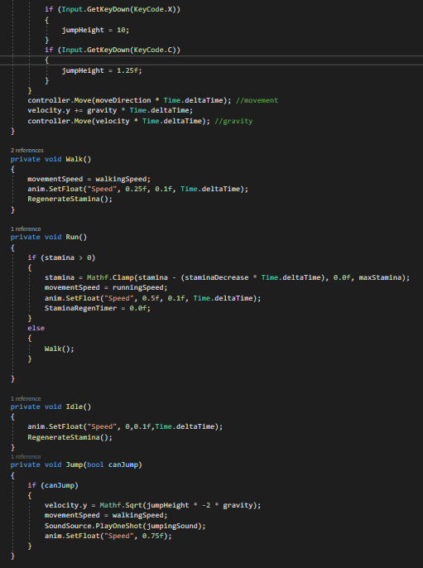

Kodas 18 MovementContoller 3

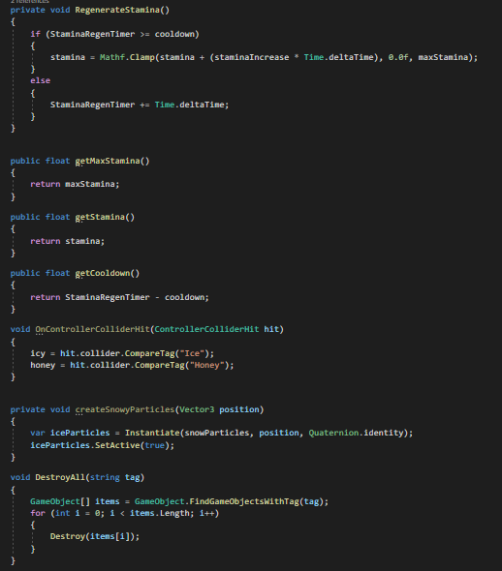

Kodas 19 MovementContoller 4

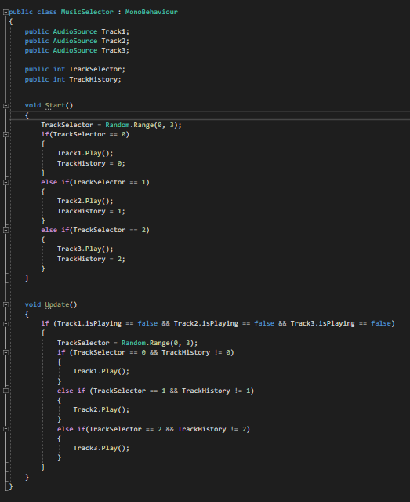

Kodas 20 MusicSelector

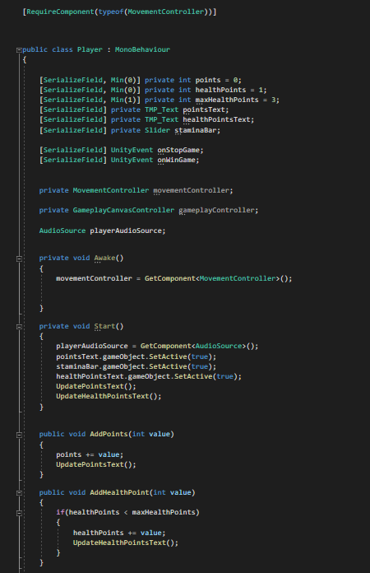

Kodas 21 Player 1

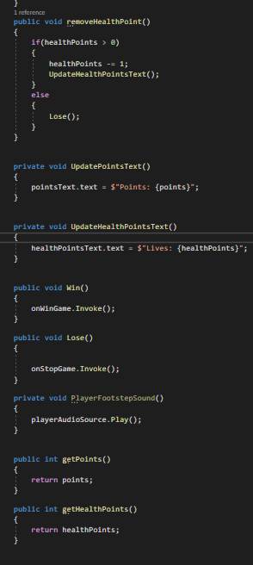

Kodas 22 Player 2

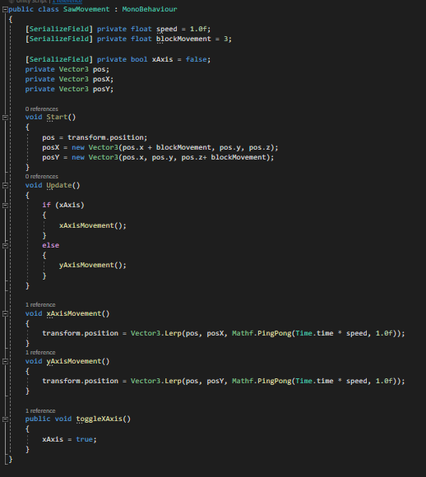

Kodas 23 SawMovement

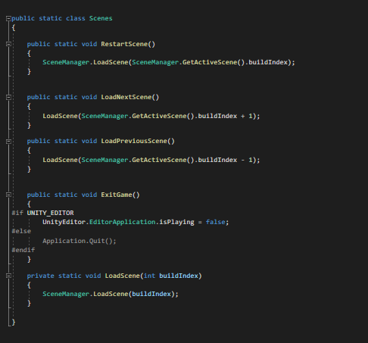

Kodas 24 Scenes

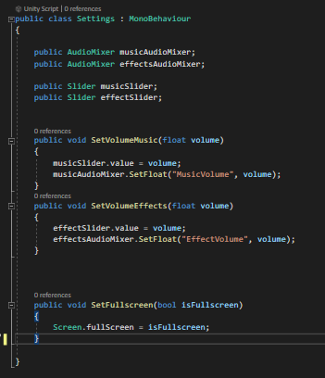

Kodas 25 Settings

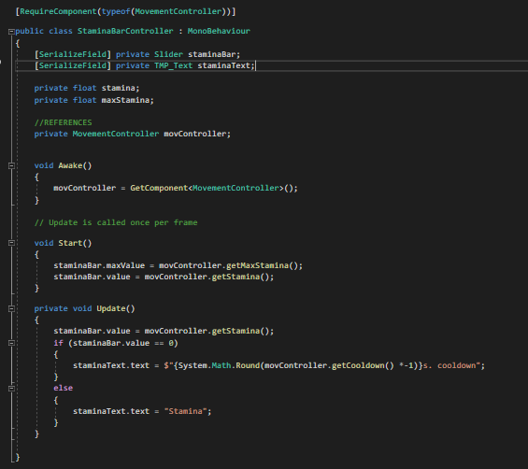

Kodas 26 StaminaBarController

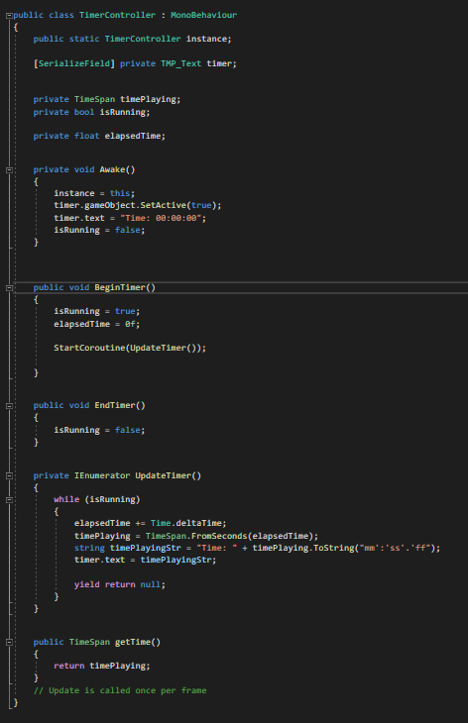

Kodas 27 TimerController

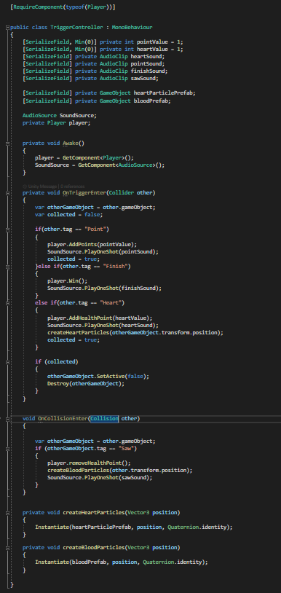

Kodas 28 TriggerController